3.12.12 Tessellation
# Source: AI Source: Provided by: [Data Path: Persons Table -> ID Column: 1, Name_En Column: Motasem Essam] -> From: [ChatGPT] on [7/25/2026]
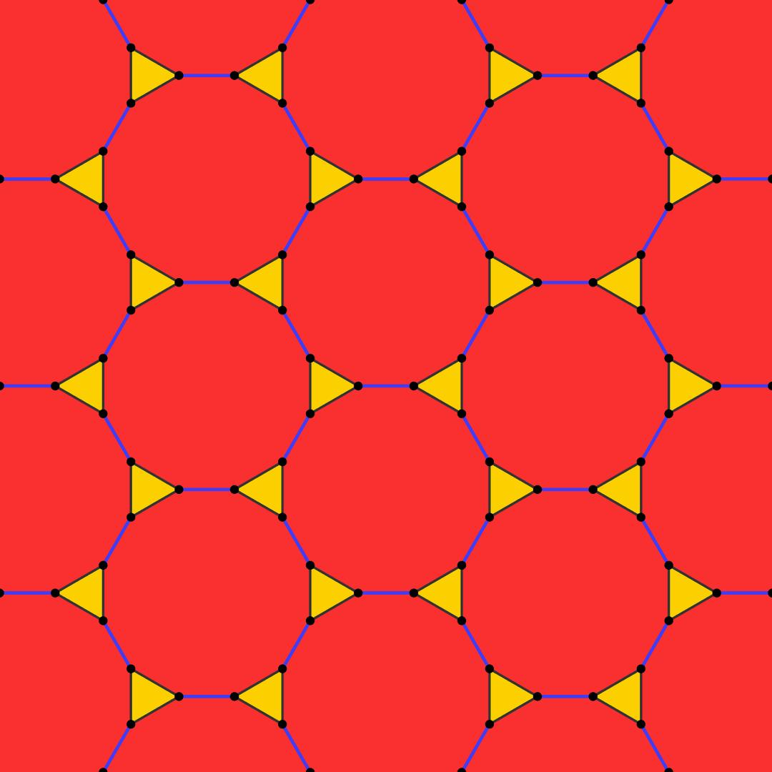
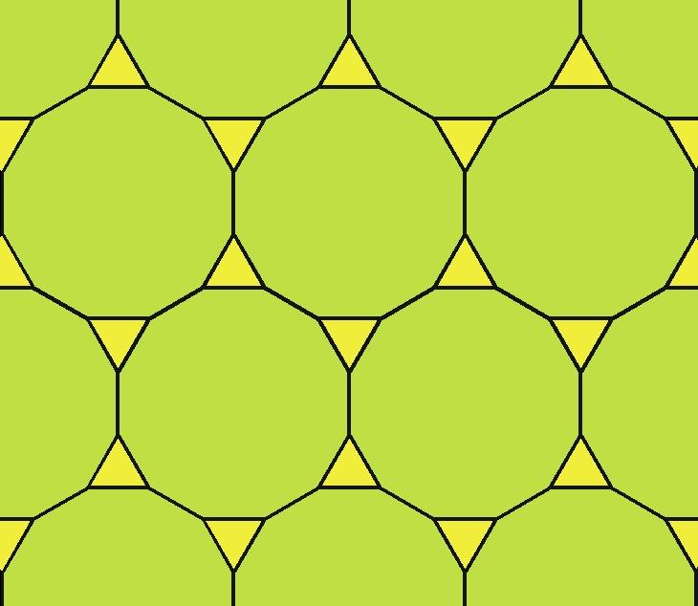
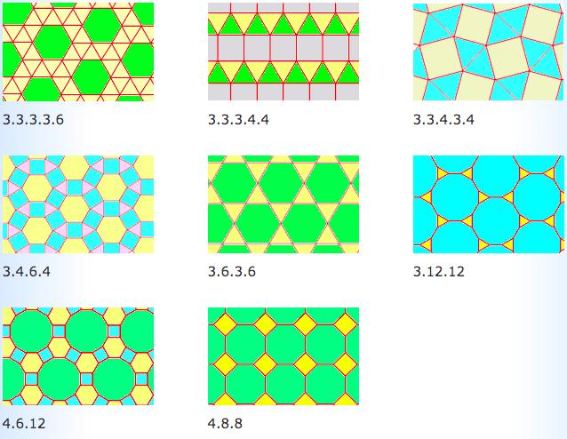
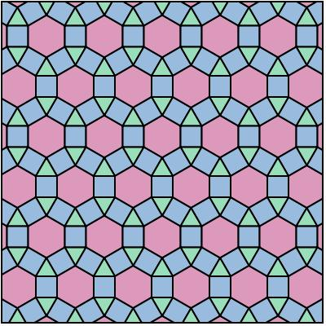

Definition
# Source: AI Source: Provided by: [Data Path: Persons Table -> ID Column: 1, Name_En Column: Motasem Essam] -> From: [ChatGPT] on [7/25/2026]
The 3.12.12 tessellation is a semi-regular (Archimedean) tessellation of the Euclidean plane composed of equilateral triangles and regular dodecagons.
Its vertex configuration is:
$$\boxed{3.12.12}$$
This means that, around every vertex, the polygons occur in the cyclic order:
Triangle → Dodecagon → Dodecagon

Basic Structure
# Source: AI Source: Provided by: [Data Path: Persons Table -> ID Column: 1, Name_En Column: Motasem Essam] -> From: [ChatGPT] on [7/25/2026]
The pattern consists of large regular dodecagons surrounded by small equilateral triangles.
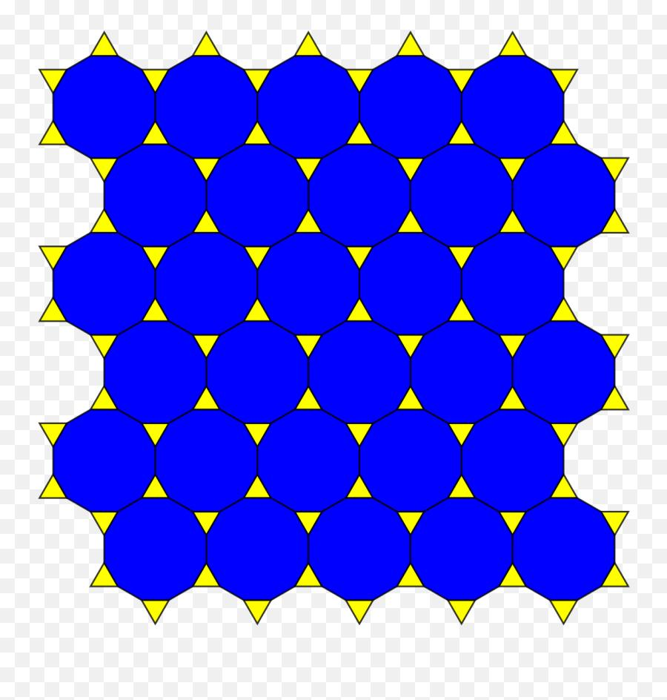
An easy way to understand its construction is:
- Start with a regular hexagonal tessellation.
- Cut off the corners of each hexagon.
- The original hexagons become regular dodecagons.
- The removed corners become equilateral triangles.
- The resulting pattern is 3.12.12. (tessell.art)

Classification
# Source: AI Source: Provided by: [Data Path: Persons Table -> ID Column: 1, Name_En Column: Motasem Essam] -> From: [ChatGPT] on [7/25/2026]
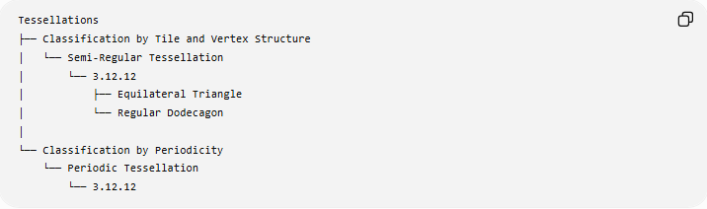
Tessellations
├── Classification by Tile and Vertex Structure
│ └── Semi-Regular Tessellation
│ └── 3.12.12
│ ├── Equilateral Triangle
│ └── Regular Dodecagon
│
└── Classification by Periodicity
└── Periodic Tessellation
└── 3.12.12
Therefore:
$$\boxed{\text{3.12.12 is Semi-Regular and Periodic}}$$

Fundamental Elements
# Source: AI Source: Provided by: [Data Path: Persons Table -> ID Column: 1, Name_En Column: Motasem Essam] -> From: [ChatGPT] on [7/25/2026]
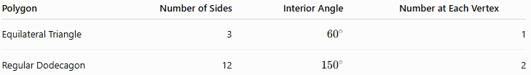
Polygon | Number of Sides | Interior Angle | Number at Each Vertex
Equilateral Triangle | 3 | $${60}^{∘}$$ | 1
Regular Dodecagon | 12 | $${150}^{∘}$$ | 2
Thus, three polygons meet at every vertex:
$$\boxed{1\text{ triangle}+2\text{ dodecagons}}$$

Vertex Angle Verification
# Source: AI Source: Provided by: [Data Path: Persons Table -> ID Column: 1, Name_En Column: Motasem Essam] -> From: [ChatGPT] on [7/25/2026]
An equilateral triangle has an interior angle of:
$${60}^{∘}$$
A regular dodecagon has an interior angle of:
$$\frac{\left(12-2\right){180}^{∘}}{12}={150}^{∘}$$
Therefore, around each vertex:
$${60}^{∘}+{150}^{∘}+{150}^{∘} \\ =\boxed{{360}^{∘}}$$
So the polygons completely fill the plane around every vertex without gaps or overlaps.

Vertex Configuration
# Source: AI Source: Provided by: [Data Path: Persons Table -> ID Column: 1, Name_En Column: Motasem Essam] -> From: [ChatGPT] on [7/25/2026]
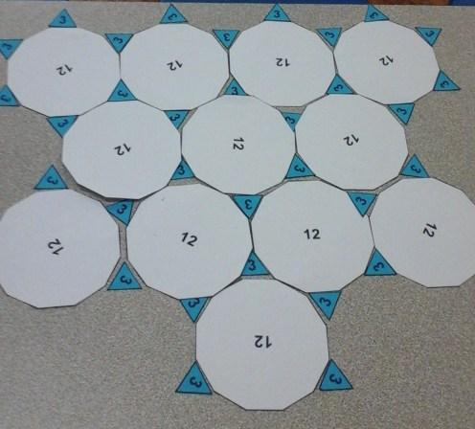
The notation
$$\boxed{3.12.12}$$
records the number of sides of the polygons encountered cyclically around a vertex:
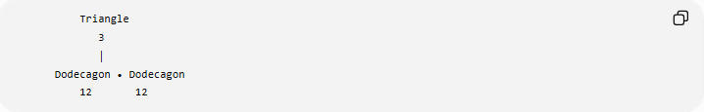
Triangle
3
│
Dodecagon • Dodecagon
12 12
The cyclic sequence is:
$$\boxed{3→12→12}$$
There is one triangle between two dodecagons around each vertex.

Why It Is Semi-Regular
# Source: AI Source: Provided by: [Data Path: Persons Table -> ID Column: 1, Name_En Column: Motasem Essam] -> From: [ChatGPT] on [7/25/2026]
The tessellation satisfies the characteristics of a semi-regular tessellation:
- All tiles are regular polygons.
- Two polygon types are used.
- The same vertex configuration occurs at every vertex.
- The polygons meet edge-to-edge.
- There are no gaps or overlaps.
Therefore:
$$\boxed{\text{3.12.12 is a Semi-Regular Tessellation}}$$

Why It Is Not Regular
# Source: AI Source: Provided by: [Data Path: Persons Table -> ID Column: 1, Name_En Column: Motasem Essam] -> From: [ChatGPT] on [7/25/2026]
A regular tessellation uses only one type of regular polygon.
The $3.12.12$tessellation uses:
- Equilateral triangles
- Regular dodecagons
Therefore:
$$\boxed{\text{3.12.12 is not a Regular Tessellation}}$$

Periodicity
# Source: AI Source: Provided by: [Data Path: Persons Table -> ID Column: 1, Name_En Column: Motasem Essam] -> From: [ChatGPT] on [7/25/2026]
The pattern repeats throughout the plane by translation.
Therefore:
$$\boxed{\text{3.12.12 is Periodic}}$$
Its combined classification is:
$$\boxed{\text{Semi-Regular + Periodic}}$$

Mathematical Representation
# Source: AI Source: Provided by: [Data Path: Persons Table -> ID Column: 1, Name_En Column: Motasem Essam] -> From: [ChatGPT] on [7/25/2026]
For a regular $n$-gon:
$$θ=\frac{\left(n-2\right){180}^{∘}}{n}$$
For the triangle:
$$θ_{3}={60}^{∘}$$
For the dodecagon:
$$θ_{12}={150}^{∘}$$
Therefore:
$$θ_{3}+2θ_{12}={360}^{∘} \\ \boxed{{60}^{∘}+2\left({150}^{∘}\right)={360}^{∘}}$$

Equivalent Compact Notation
# Source: AI Source: Provided by: [Data Path: Persons Table -> ID Column: 1, Name_En Column: Motasem Essam] -> From: [ChatGPT] on [7/25/2026]
The vertex configuration can also be written as:
$$\boxed{{3.12}^{2}}$$
This indicates:
- $3$→ one triangle
- ${12}^{2}$→ two dodecagons
The expanded form
$$\boxed{3.12.12}$$
makes the cyclic sequence explicit.

Important Structural Feature
# Source: AI Source: Provided by: [Data Path: Persons Table -> ID Column: 1, Name_En Column: Motasem Essam] -> From: [ChatGPT] on [7/25/2026]
The dodecagon has a very large interior angle:
$${150}^{∘}$$
Two dodecagons contribute:
$${150}^{∘}+{150}^{∘}={300}^{∘}$$
leaving exactly:
$${360}^{∘}-{300}^{∘}={60}^{∘}$$
for the equilateral triangle.
Thus:
$$\boxed{{60}^{∘}+{300}^{∘}={360}^{∘}}$$
This is why the three polygons can meet perfectly at each vertex.

Comparison with Other Semi-Regular Tessellations
# Source: AI Source: Provided by: [Data Path: Persons Table -> ID Column: 1, Name_En Column: Motasem Essam] -> From: [ChatGPT] on [7/25/2026]
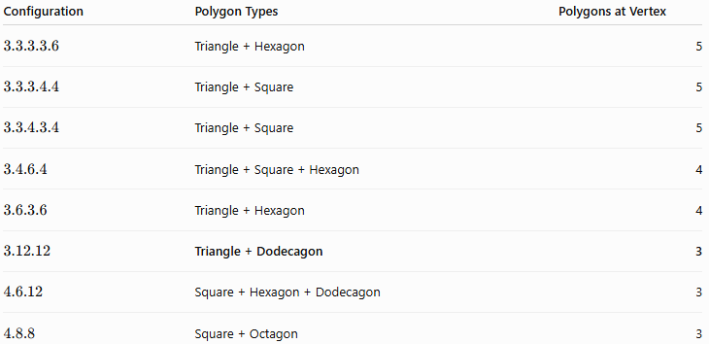
Configuration | Polygon Types | Polygons at Vertex
$$3.3.3.3.6$$ | Triangle + Hexagon | 5
$$3.3.3.4.4$$ | Triangle + Square | 5
$$3.3.4.3.4$$ | Triangle + Square | 5
$$3.4.6.4$$ | Triangle + Square + Hexagon | 4
$$3.6.3.6$$ | Triangle + Hexagon | 4
$$3.12.12$$ | Triangle + Dodecagon | 3
$$4.6.12$$ | Square + Hexagon + Dodecagon | 3
$$4.8.8$$ | Square + Octagon | 3

Comparison with $4.6.12$
# Source: AI Source: Provided by: [Data Path: Persons Table -> ID Column: 1, Name_En Column: Motasem Essam] -> From: [ChatGPT] on [7/25/2026]
Both $3.12.12$and $4.6.12$have three polygons at each vertex, but they use different polygons.
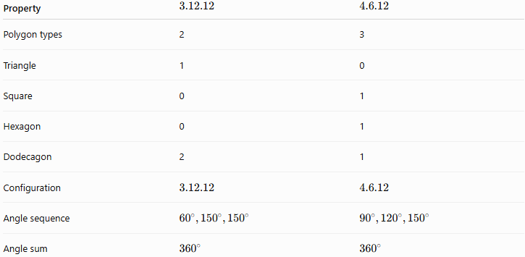
Property | $$3.12.12$$ | $$4.6.12$$
Polygon types | 2 | 3
Triangle | 1 | 0
Square | 0 | 1
Hexagon | 0 | 1
Dodecagon | 2 | 1
Configuration | $$3.12.12$$ | $$4.6.12$$
Angle sequence | $${60}^{∘},{150}^{∘},{150}^{∘}$$ | $${90}^{∘},{120}^{∘},{150}^{∘}$$
Angle sum | $${360}^{∘}$$ | $${360}^{∘}$$

Key Properties
# Source: AI Source: Provided by: [Data Path: Persons Table -> ID Column: 1, Name_En Column: Motasem Essam] -> From: [ChatGPT] on [7/25/2026]
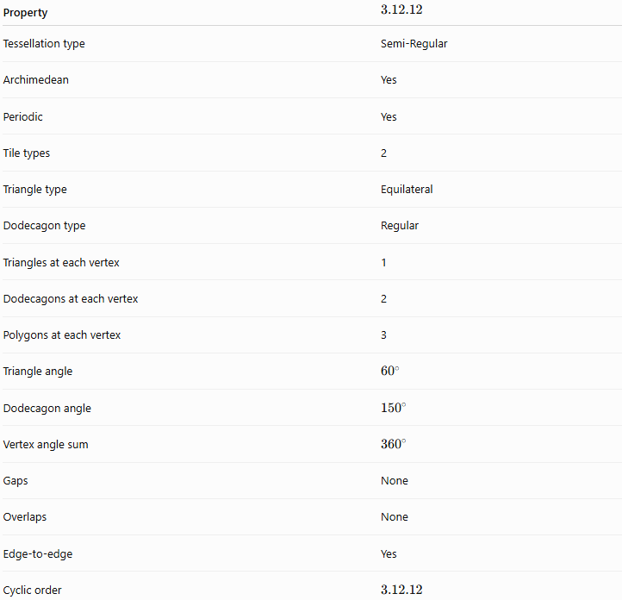
Property | $$3.12.12$$
Tessellation type | Semi-Regular
Archimedean | Yes
Periodic | Yes
Tile types | 2
Triangle type | Equilateral
Dodecagon type | Regular
Triangles at each vertex | 1
Dodecagons at each vertex | 2
Polygons at each vertex | 3
Triangle angle | $${60}^{∘}$$
Dodecagon angle | $${150}^{∘}$$
Vertex angle sum | $${360}^{∘}$$
Gaps | None
Overlaps | None
Edge-to-edge | Yes
Cyclic order | $$3.12.12$$

Relationship to the Eight Semi-Regular Tessellations
# Source: AI Source: Provided by: [Data Path: Persons Table -> ID Column: 1, Name_En Column: Motasem Essam] -> From: [ChatGPT] on [7/25/2026]
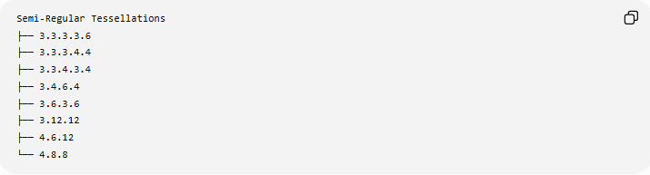
Semi-Regular Tessellations
├── 3.3.3.3.6
├── 3.3.3.4.4
├── 3.3.4.3.4
├── 3.4.6.4
├── 3.6.3.6
├── 3.12.12
├── 4.6.12
└── 4.8.8
The $3.12.12$tessellation is therefore one of the eight Archimedean tessellations of the Euclidean plane.

Key Points
# Source: AI Source: Provided by: [Data Path: Persons Table -> ID Column: 1, Name_En Column: Motasem Essam] -> From: [ChatGPT] on [7/25/2026]
- $3.12.12$is a semi-regular (Archimedean) tessellation.
- It uses:
  - Equilateral triangles
  - Regular dodecagons
- Three polygons meet at every vertex.
- The configuration is:
$$\boxed{3.12.12}$$
- The angles are:
$${60}^{∘}, {150}^{∘}, {150}^{∘}$$
- Their sum is:
$$\boxed{{360}^{∘}}$$
- It is also periodic.
- Its compact notation is:
$$\boxed{{3.12}^{2}}$$

Conclusion
# Source: AI Source: Provided by: [Data Path: Persons Table -> ID Column: 1, Name_En Column: Motasem Essam] -> From: [ChatGPT] on [7/25/2026]
The 3.12.12 tessellation is a semi-regular, periodic tessellation consisting of equilateral triangles and regular dodecagons. At every vertex, one triangle and two dodecagons meet in the cyclic configuration
$$\boxed{3.12.12}$$
and their interior angles satisfy
$$\boxed{{60}^{∘}+{150}^{∘}+{150}^{∘}={360}^{∘}}$$
allowing the polygons to cover the Euclidean plane completely without gaps or overlaps.

